Ideation Phase
Define the Problem Statements

Date | 31 January 2025
Team ID | SWTID-2026-3395
Project Name | Visualizing Housing Market Trends
Maximum Marks | 2 Marks

Customer Problem Statement Template:
Create a problem statement to understand your customer's point of view. The Customer Problem Statement template helps you focus on what matters to create experiences people will love.
Problem  Statement (PS) | I am  (Customer) | I’m trying to | But | Because | Which makes me feel
PS-1 | Visualizing Housing Market Trends | Find an affordable house in a good location | There is too much housing data to compare | Market information is scattered across multiple sources | Confused and overwhelmed
PS-2 | A real estate investor | Identify profitable areas for investment | Housing price trends are difficult to analyze | Data is complex and changes frequently | Uncertain about investment decisions
A well-articulated customer problem statement allows you and your team to find the ideal solution for the challenges your customers face. Throughout the process, you’ll also be able to empathize with your customers, which helps you better understand how they perceive your product or service.
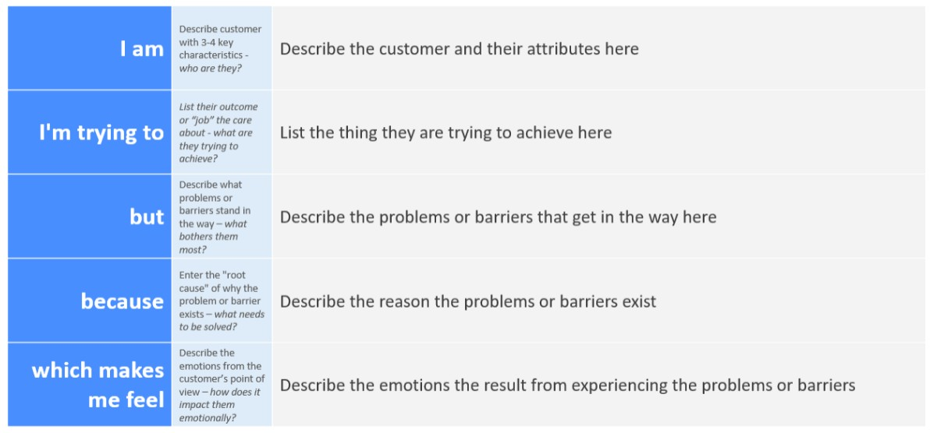
Reference: https://miro.com/templates/customer-problem-statement/ Example:


